Knowledge and Nostalgia: Workshop by Alumnae
Adagio, the Choreography Society of Kamala Nehru College, undertook a unique initiative of organising an Alumnae engagement session on February 28th, 2024. In the session, alumnae were engaged as resource persons in conducting a dance workshop for KNC students.
The current students were introduced to beginner-level contemporary dance form by the trained alumnae members of Adagio.
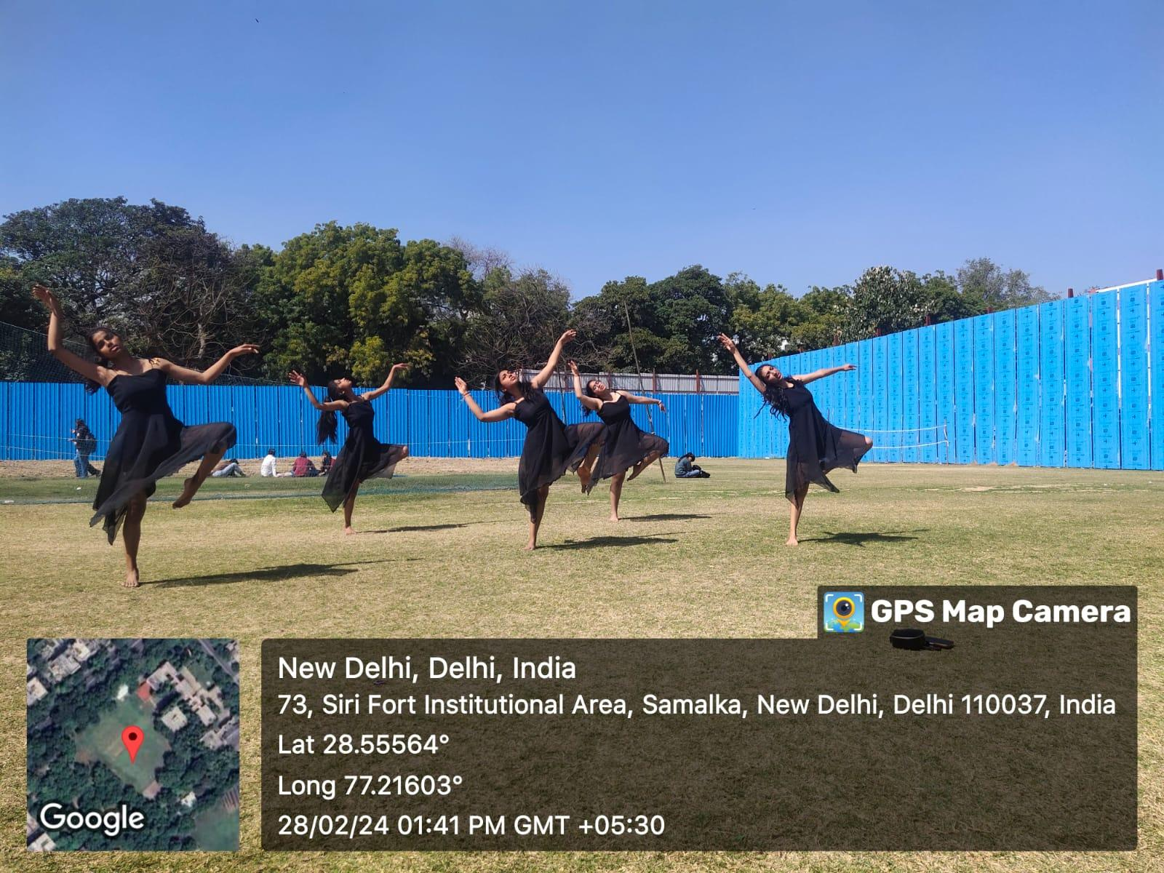
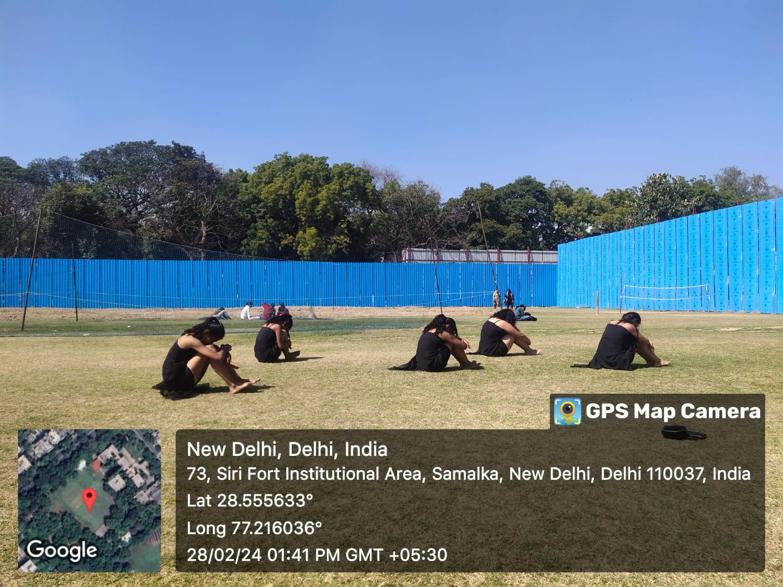
The workshop began with a warm-up routine, focusing on stretching exercises and dynamic movements to prepare the participants physically for the choreography.
The choreography itself was taught step by step, emphasizing technique and expression, and the attendees showed great enthusiasm in learning, expressing their admiration for the choreography.
The interaction with alumnae members from the batch of 2022, Ms. Ayana Malhotra and Ms. Rhea Sharma. Ms. Ayana is currently pursuing her passion for dance and aspiring to become a choreographer, she conducted the session on basic ballet techniques, drawing from her extensive experience. Participants got the opportunity to learn from her insights and refine their skills.
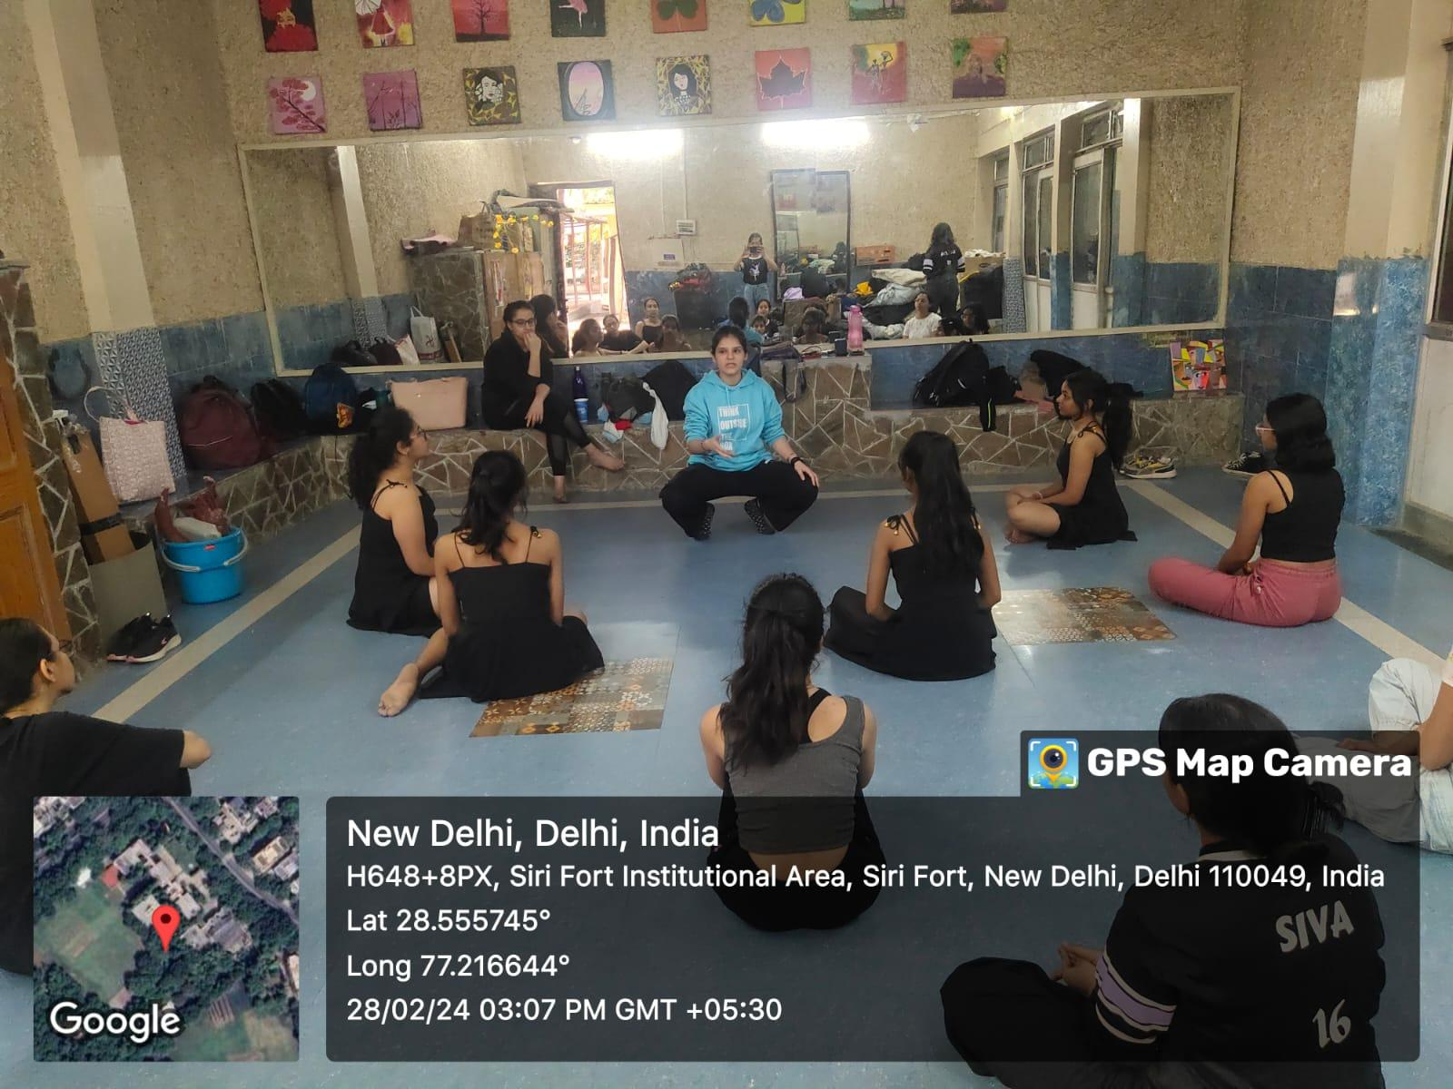
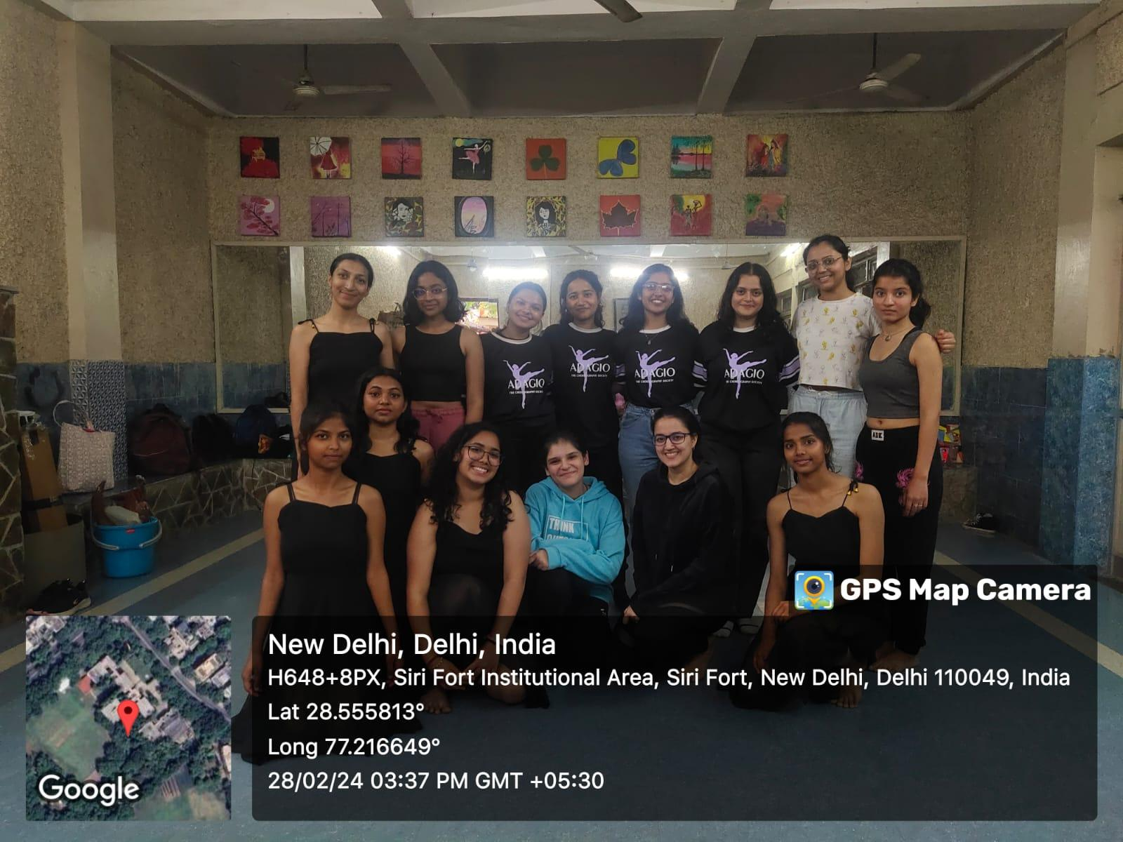
Overall, the workshop was a resounding success, achieving its objectives of introducing contemporary dance to beginners. Participants learned the choreography with enthusiasm and enjoyed the interactive sessions with alumnae. It also fostered a sense of community and continuity with Adagio's legacy. The workshop showcased the society's commitment to promoting dance and engaging its members, uniting individuals and creating memorable experiences for all involved. It served as an inspiring platform for aspiring dancers to learn, grow, and connect with the rich tradition of dance and culture at Kamala Nehru College.
Beginner-Friendly Contemporary Dance

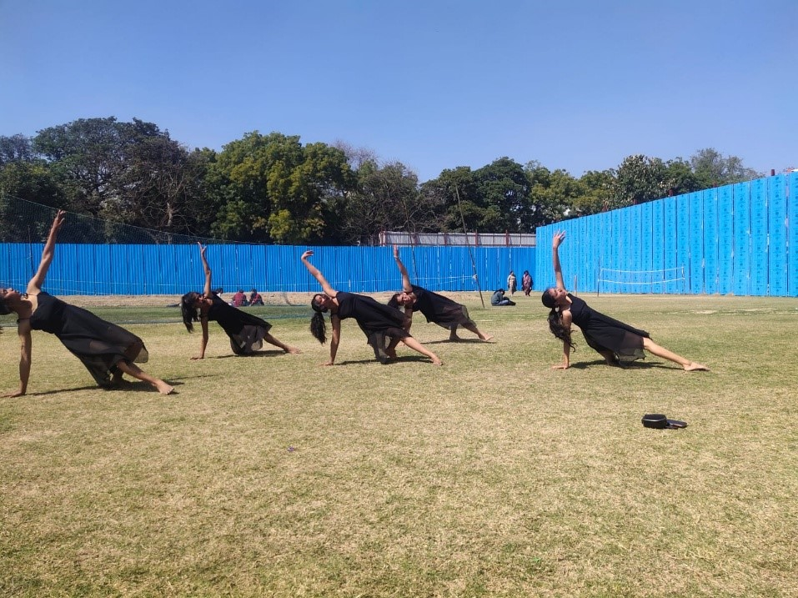

As part of an initiative to promote creativity and well-being among students, Adagio, the choreography society of Kamala Nehru College, conducted a beginner-friendly contemporary dance workshop. This workshop aimed to provide KNC students with a break from the routine pressures of academics, allowing them to unwind, explore creativity, and experience the joy of dance in a stress-free environment.
The workshop featured a self-curated choreography tailored for beginners, ensuring an inclusive space for all, irrespective of prior dance experience. Unlike society rehearsals that require extensive time commitments, this session was designed to be light, fun, and engaging, giving students the freedom to participate without the pressure of joining the society. It was later featured in Hindustan Times as a unique initiative.

